**VELAMMAL ENGINEERING COLLEGE**

# (An Autonomous Institution)

**CHENNAI–600066**



**NAAN MUDHALVAN**

**For   
1st YEAR B.E / B.Tech Students**

Organized By

DEPARTMENT OF

PHYSICS

SUBMITTED TO

 INSTITUTION'S INNOVATION COUNCIL

# VELAMMAL ENGINEERING COLLEGE

**(An Autonomous Institution)**

**Department of Physics**

1. Title of the Event : Naan Mudhalvan for 1st year B.E / B.Tech Students
2. Resource Person **: Gowrishankar**

3. Date : 29-04- 2024 (9.30 AM – 3.15 PM)

1. Session Type : Offline Zoom
2. Program Type : offline Presentation
3. Annexure- I : List of Participants
4. Annexure- II : Broucher, Registration Form
5. Annexure- III : Photographs
6. Annexure- IV : Participants Feedback

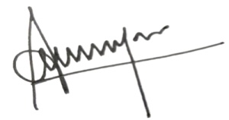



|  |  |
| --- | --- |
| **Dr. J. Arumugam**  Event Coordinator  Department of Physics | **Dr. S. Shahil Kirupavathy**  Professor & Head  Department of Physics |

**ANNEXURE-I**

Velammal Engineering College

Department of Physics

List of Participants: All 1st Years

# ANNEXURE –II

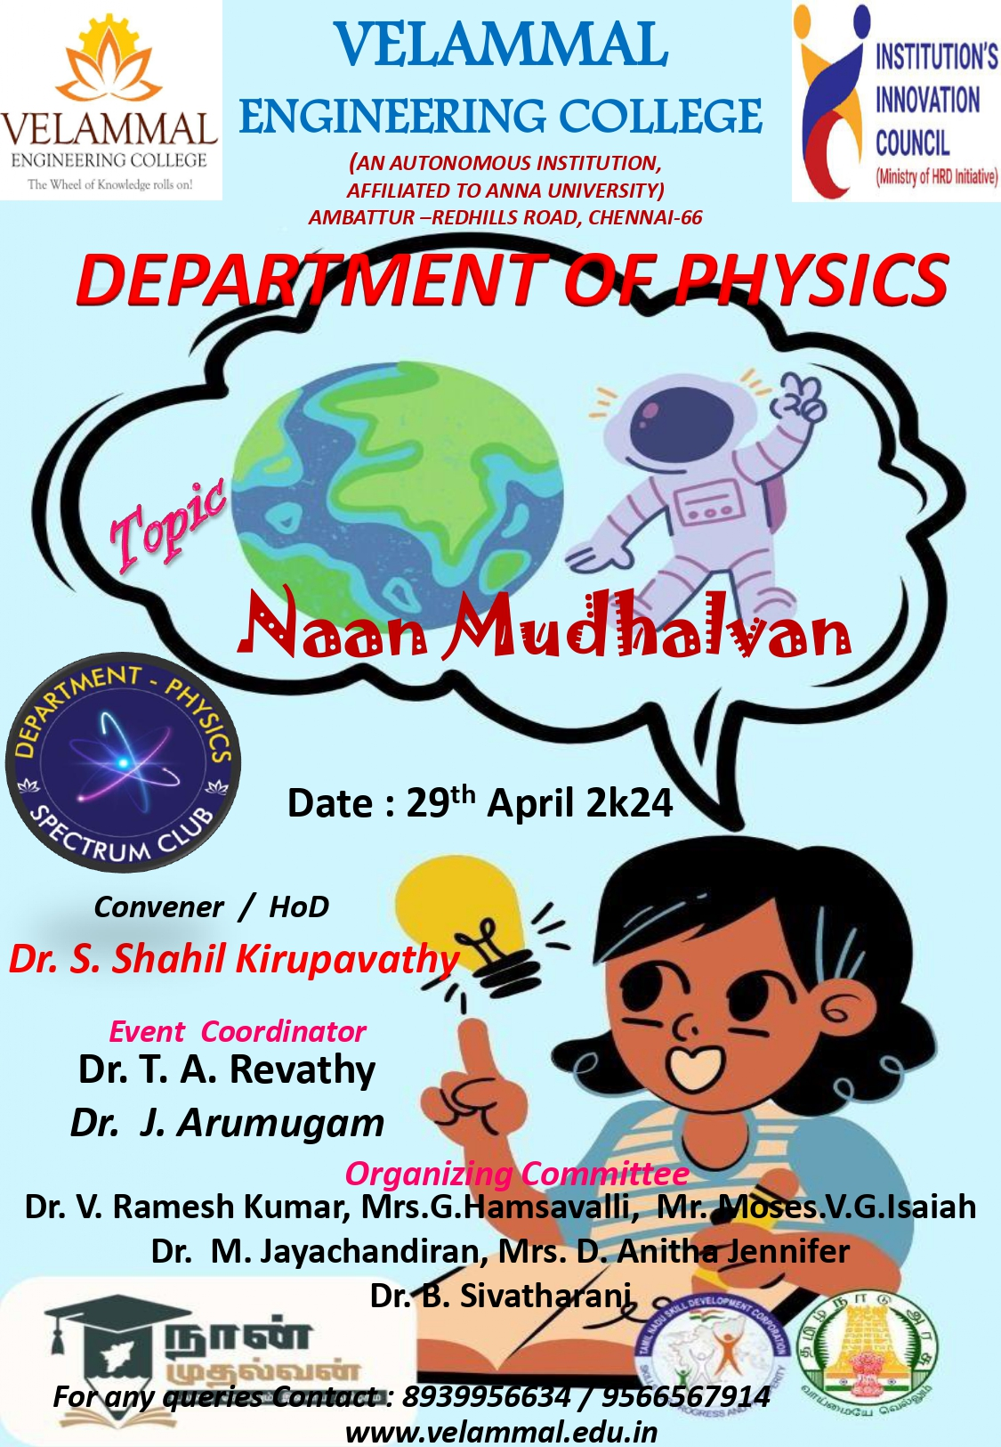

**Figure 1: Naan Mudhalvan for 1st year VEC students**

**ANNEXURE –III**

**Photographs**

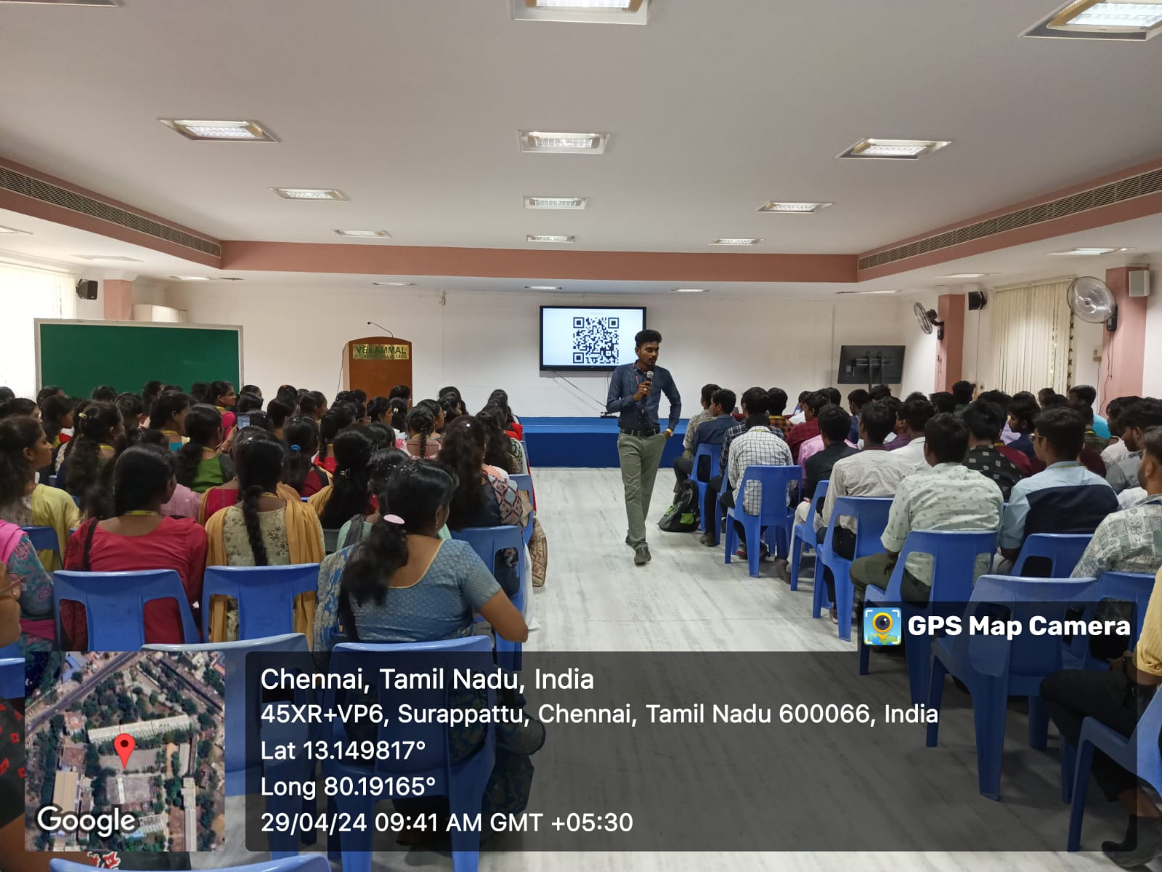

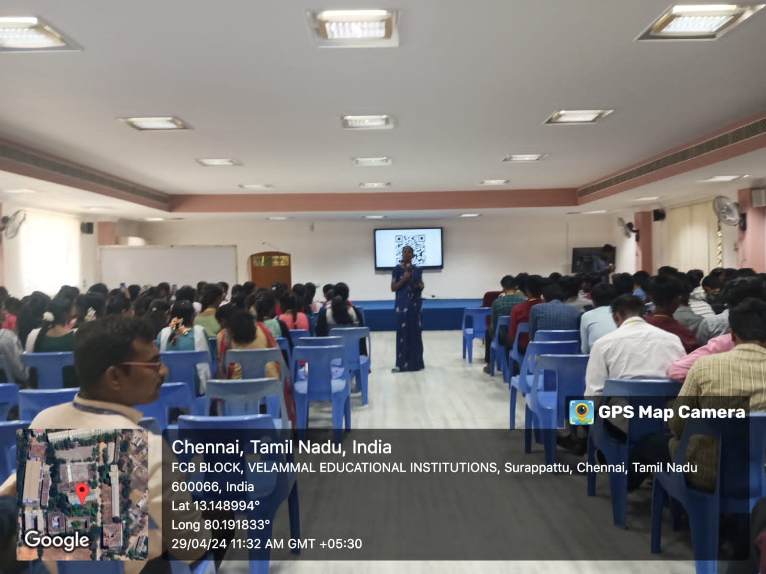

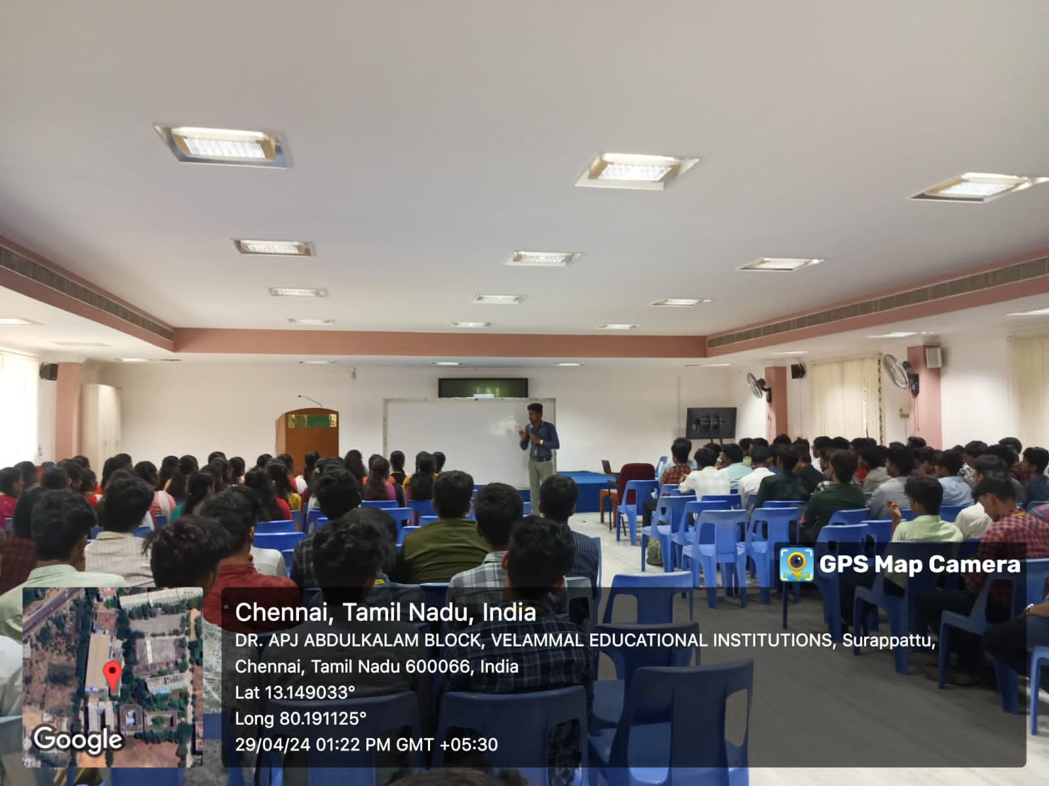

**Figure 2: photograph of the event**

**ANNEXURE –IV**

**Table 1: Participants Feedback**

| **Sl.No** | **NAME** | **How was the Quiz?** |
| --- | --- | --- |
| 1 | AADHI. K | Good |
| 2 | BALAVIGINESH. R | Useful |
| 3 | DEEPAK. S | Excellent |
| 4 | PREETHI. M | Knowledgeable |
| 5 | PRIYA DHARSHINI. R | Good |
| 6 | YAZHINI. R | Useful |
| 7 | DHARSHINI. A | Excellent |
| 8 | SUKUL. S | Good |
| 9 | NANDHAKARTHIKA. M | Informative |
| 10 | SURENDRAN. M | Very Good |